

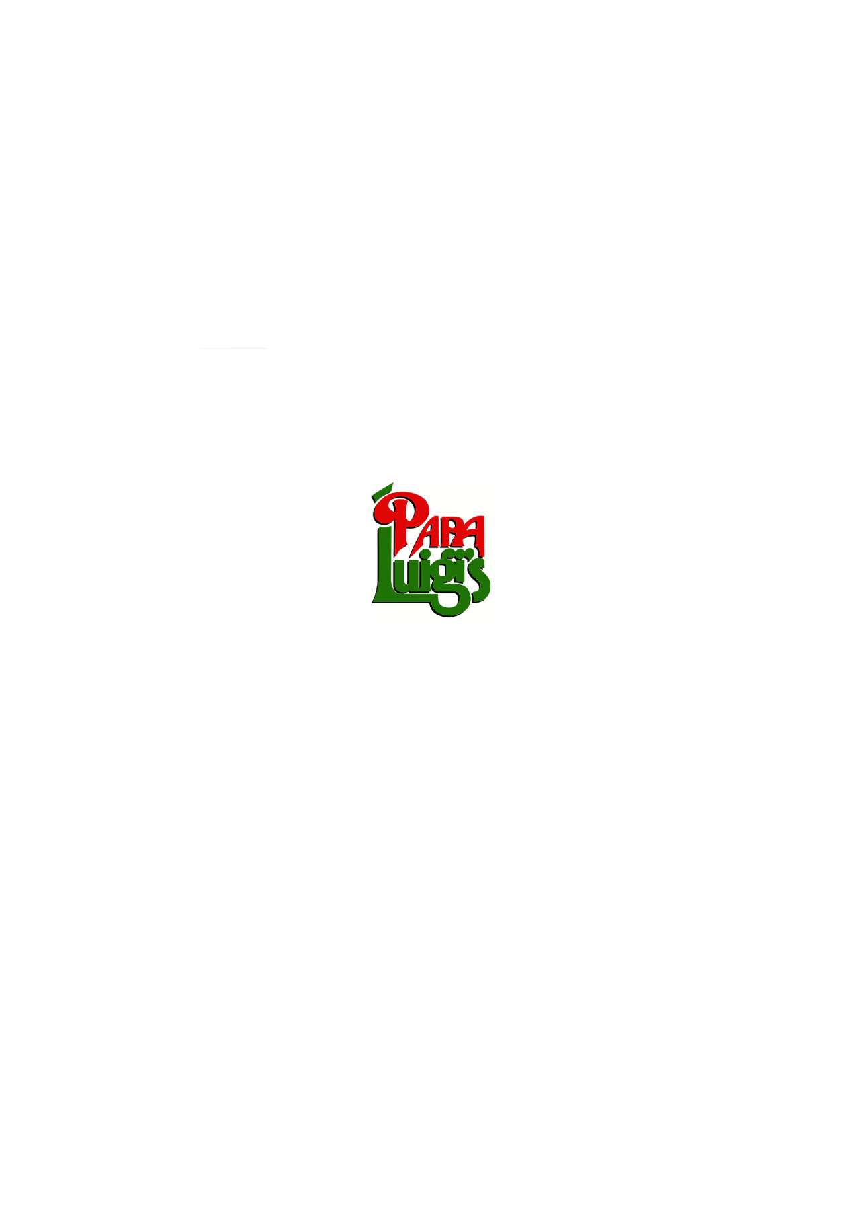





**CHRISTMAS & FESTIVE MENUS**



**PAPA LUIGI’S EUXTON**

**169 WIGAN ROAD**

**EUXTON CHORLEY**

**LANCASHIRE**

**PR7 6JH**

**01257 262644**

[**www.papaluigis.co.uk**](http://www.papaluigis.co.uk)

**papaluigiseuxton@outlook.com**

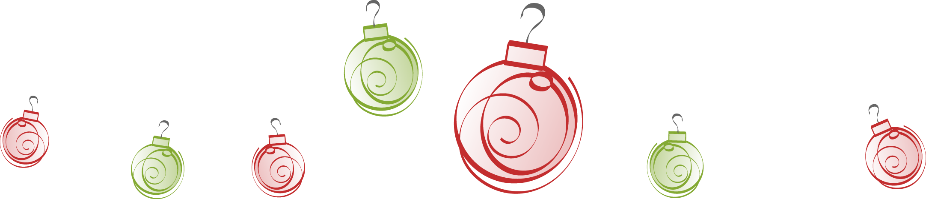

**CHRISTMAS DAY MENU**

**STARTERS**

**Parfait Di Fegato D’Anatra E Porto**

A smooth homemade duck liver and port parfait served with toasted bread and a sweet date and pear chutney

**Budino Nero Bon Bons**

Black pudding bon bons in a gorgonzola cream sauce sat on a bed of apple and sweet potato mash

**Risotto Con Funghi Portobello E Asparagi**

Fresh Portobello mushrooms and grilled asparagus spears with freshly cooked Arborio rice and a touch of cream

**Millefoglie Di Salmone**

Scottish smoked salmon layered with a mascarpone dill cream served with a cucumber and lemon berry terrine

**Zuppa Di Verdure Invernali**

A homemade winter vegetable and lentil soup served with freshly baked bread and croutons

**MAIN COURSES**

**Tacchino Arrosto**

Roasted turkey crown served with homemade turkey gravy and stuffing

and accompanied with pigs in blankets, roasted parsnips, carrots, sprouts and roast potatoes

**Coda Di Rospo Di Prosecco**

A pan fried monkfish steak with grilled scallops and sat on a bed of Prosecco infused leek and cream jus

**Medaglioni Ai Funghi**

Prime medallions of fillet steak, cooked medium, accompanied with a light mixed wild mushroom sauce

served with roast potatoes and vegetables

**Funghi E Zucca**

Mixed wild mushrooms and butternut squash wrapped in puff pastry, smothered with a creamy mushroom sauce

And served with roast potatoes and vegetables

**A small selection of Pizza’s or Pasta Dishes is available for children**

**DESSERTS**

**A selection of Papa’s favourite desserts**