

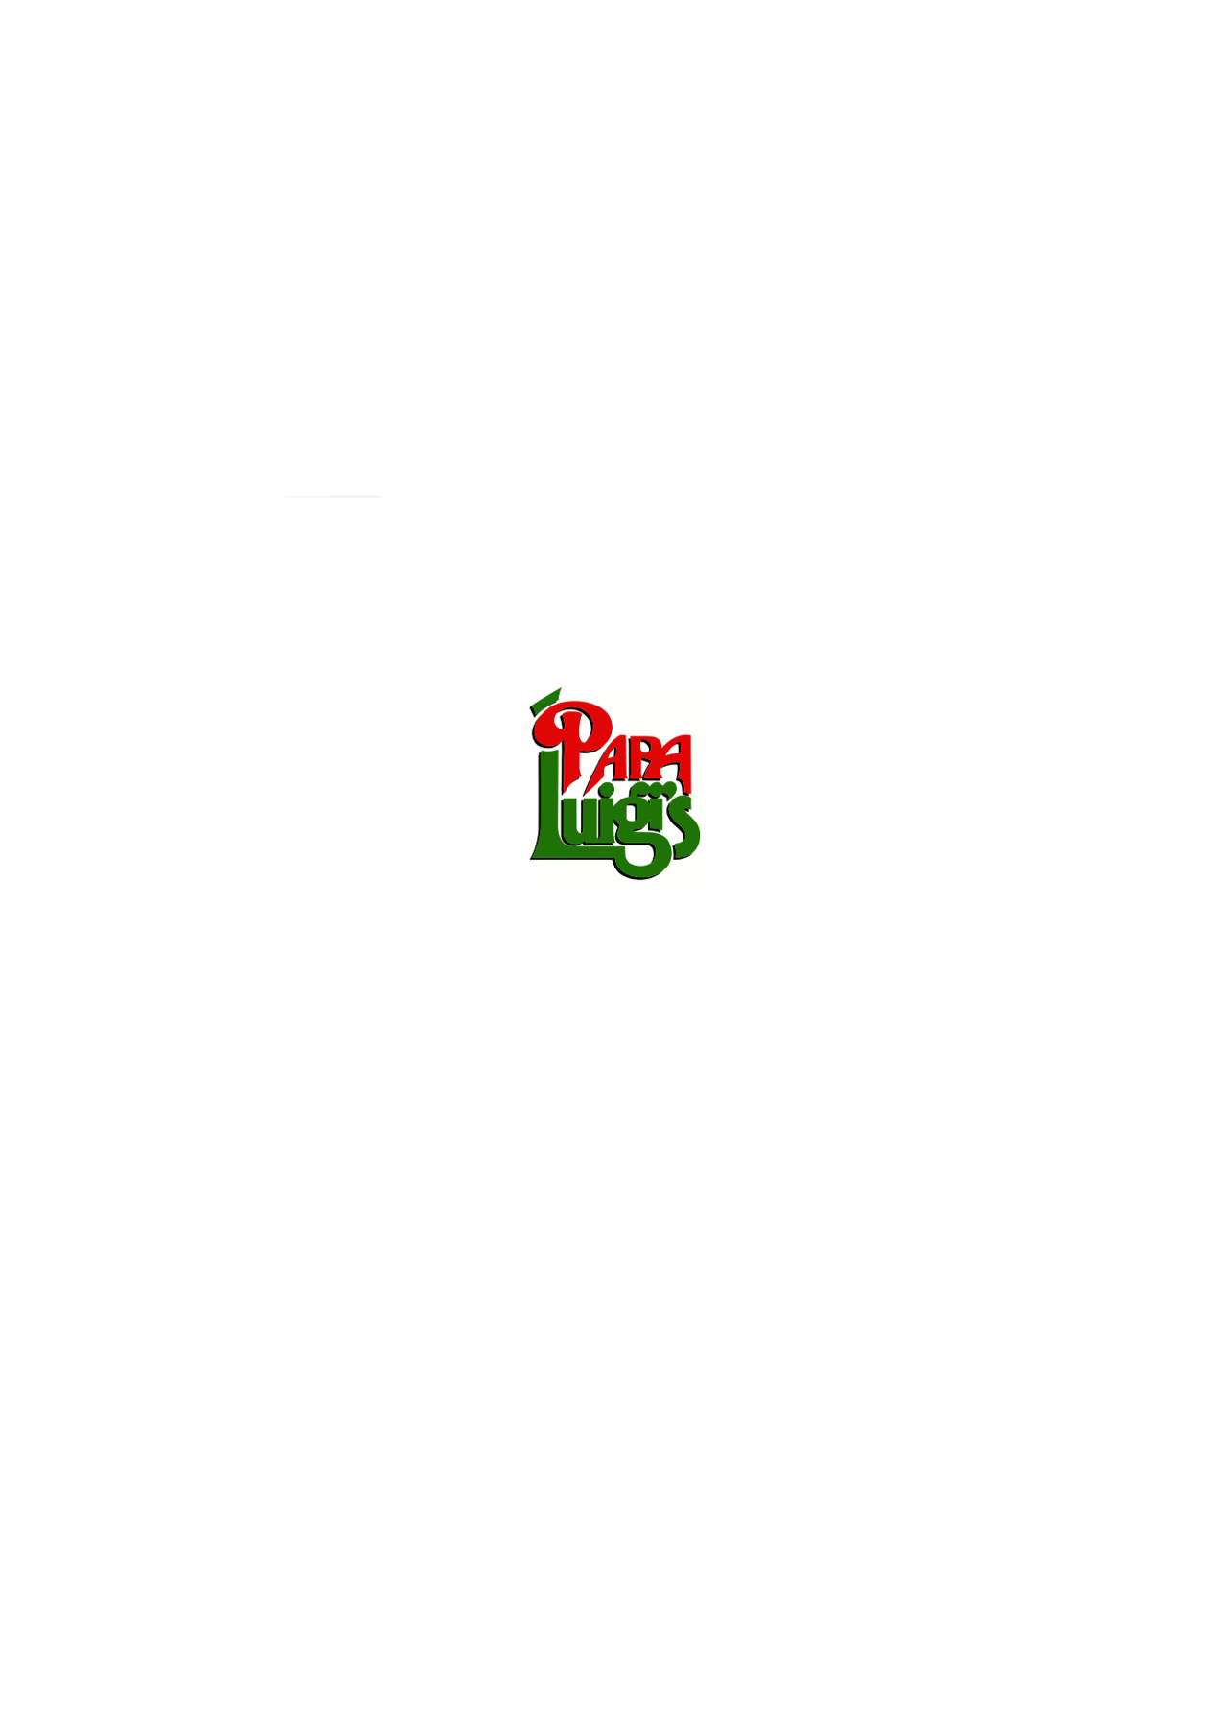





**CHRISTMAS & FESTIVE MENUS**



**PAPA LUIGI’S EUXTON**

**169 WIGAN ROAD**

**EUXTON CHORLEY**

**LANCASHIRE**

**PR7 6JH**

**01257 262644**

[**www.papaluigis.co.uk**](http://www.papaluigis.co.uk)

**papaluigiseuxton@outlook.com**

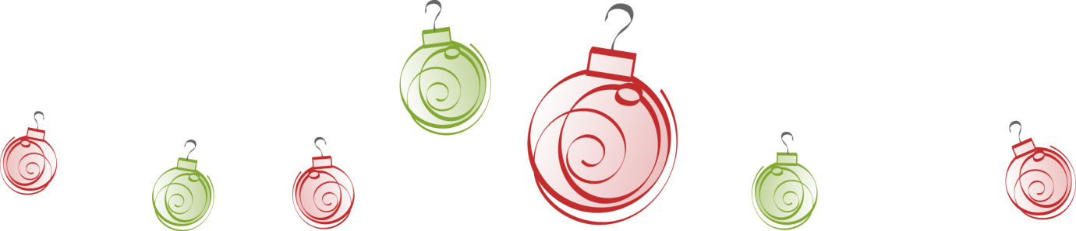

**CHRISTMAS PARTY EVENING MENU**

(Tuesday – Sunday evenings throughout December)

**STARTERS**

**Zuppa Del Giorno**

Homemade soup of the day served with fresh homemade bread

**Funghi Gorgonzola**

Fresh mushrooms oven baked and stuffed with garlic parsley butter, breadcrumbs and parmesan

topped with gorgonzola cheese

**Parfait Di Fegato Di Anatra**

Homemade duck liver parfait served with toast and a homemade winter berry coulis

**Caprino In Filo**

Goats cheese wrapped in filo pastry, deep fried and served on a tomato bruschetta

**Salmone Affumicato Millefoglie**

Fresh Scottish smoked salmon layered with mascarpone and fresh dill

**MAIN COURSES**

**Tacchino Arrosto**

Roasted turkey crown served with homemade turkey gravy and stuffing

and accompanied with pigs in blankets, roasted parsnips, carrots, sprouts and roast potatoes

**Filetto Di Branzino**

Fresh sea bass fillets, pan fried in a Prosecco, King prawn and cream sauce

**Agnello Henry**

A prime shoulder of lamb slow cooked with a red wine and mint jus

served with roast potatoes and vegetables

**Pollo Papa Luigi’s**

A succulent pan fried chicken breast with any sauce from our a la carte menu

served with roast potatoes and vegetables

**Medaglioni Di Maiale**

Tender pork medallions cooked in a creamy wild mushroom sauce

served with roast potatoes and vegetables

**Any Pizza or Pasta from our A La Carte menu**

**DESSERTS**

**A selection of Papa’s desserts will be available**

**£21.95 p/p**

**3-courses**